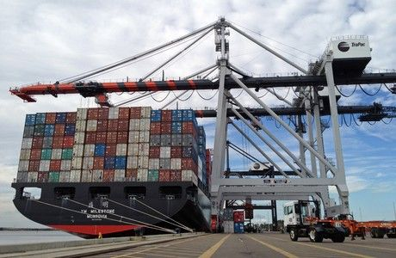
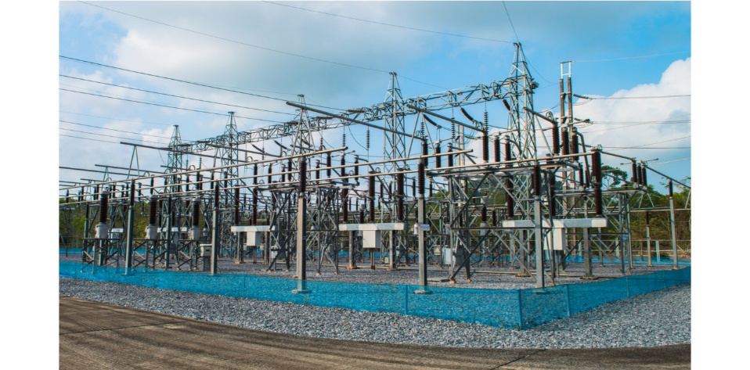
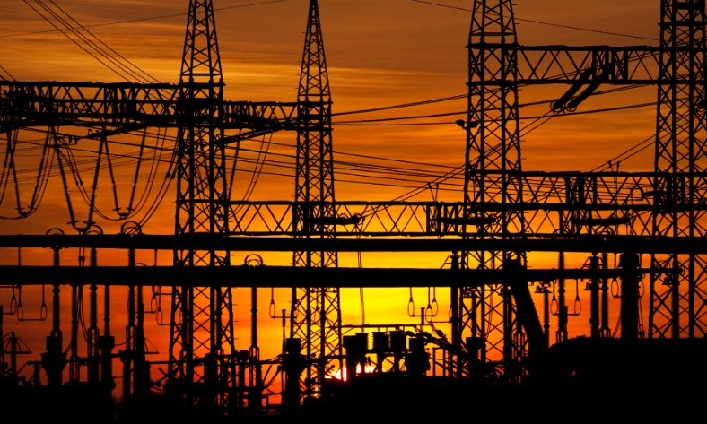
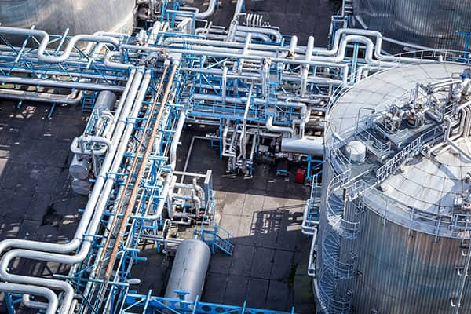
Asset Dependency Assessment

WARNING: This information is FOR OFFICIAL USE ONLY (FOUO). It contains information that may be exempt from public release under the Freedom of Information act (5 U.S.C. § 552). It is to be controlled, stored, handled, transmitted, distributed, and disposed of in accordance with U.S. Department of Homeland Security (DHS) Management Directive 11042.1 relating to FOUO information and is not to be released to the public or other personnel who do not have a valid “Need-to-know” without prior approval of an authorized DHS official.

Version: Alpha V3
Cybersecurity and Infrastructure Security Agency
[[PSA_NAME]]
Protective Security Advisor
Department of Homeland Security
Cybersecurity and Infrastructure Security Agency
Integrated Operations Division | Region [[PSA_REGION]] | [[PSA_CITY]]
Cell: [[PSA_CELL]]
Email: [[PSA_EMAIL]]

Contents
PART I – EXECUTIVE DEPENDENCY RISK BRIEF 2
A. EXECUTIVE RISK POSTURE 2
B. DEPENDENCY SNAPSHOT TABLE 2
C. CROSS-INFRASTRUCTURE SYNTHESIS 3
D. PRIORITY ACTIONS 3
PART II – TECHNICAL ANNEX 4
DEPENDENCY SUMMARY 4
CORE INFRASTRUCTURE OVERVIEW 4
INTERNET TRANSPORT 4
CRITICAL HOSTED SERVICES 4
STRUCTURAL RISK PROFILE 4
INFRASTRUCTURE VULNERABILITIES 4
CROSS-INFRASTRUCTURE ANALYSIS 4

PART I – EXECUTIVE DEPENDENCY RISK BRIEF

EXECUTIVE RISK POSTURE

[[SNAPSHOT_POSTURE]]
[[SNAPSHOT_SUMMARY]]
[[SNAPSHOT_DRIVERS]]

B. DEPENDENCY SNAPSHOT TABLE

[[SNAPSHOT_MATRIX]]
[[SNAPSHOT_CASCADE]]
[[CHART_ELECTRIC_POWER]]
[[CHART_COMMUNICATIONS]]
[[CHART_INFORMATION_TECHNOLOGY]]
[[CHART_WATER]]
[[CHART_WASTEWATER]]

C. CROSS-INFRASTRUCTURE SYNTHESIS

[[SYNTHESIS]]

D. PRIORITY ACTIONS

[[PRIORITY_ACTIONS]]

PART II – TECHNICAL ANNEX

DEPENDENCY SUMMARY

CORE INFRASTRUCTURE OVERVIEW
[[TABLE_DEPENDENCY_SUMMARY]]

INTERNET TRANSPORT
[[IT_TRANSPORT_SECTION]]

CRITICAL HOSTED SERVICES
[[IT_HOSTED_SECTION]]

STRUCTURAL RISK PROFILE
[[STRUCTURAL_PROFILE_SUMMARY]]

INFRASTRUCTURE VULNERABILITIES
[[VULNERABILITY_COUNT_SUMMARY]]
[[VULNERABILITY_BLOCKS]]
[[VULN_NARRATIVE]]

CROSS-INFRASTRUCTURE ANALYSIS
[[CROSS_INFRA_ANALYSIS]]

